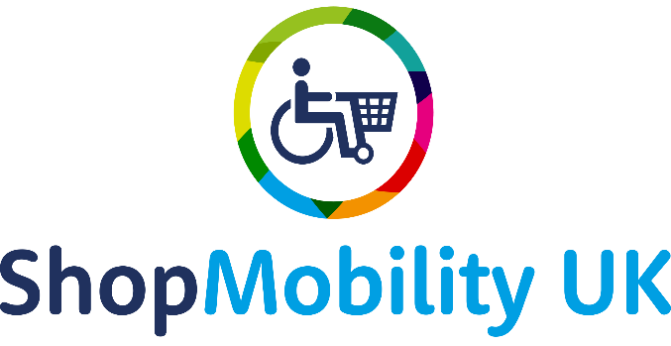

LIST OF BENEFITS

Authorisation to use the ShopMobility word and symbol (UK Registered Trademark) on promotional and other material.

Use of the ShopMobility word and symbol TM on highway signs to your scheme, meeting the Department for Transport criteria.

Credibility and support from being part of the Driving Mobility Code of Practise and complaints procedure.

Certificate of Membership valid for a year from issue.

Inclusion in the ShopMobility UK online directory with full details of services listed on the website (and downloadable directory where available).

Access to preferential insurance rates from Gallagher for your ShopMobility Scheme.

Online Newsletter circulated monthly, bringing you news, views and tips from the industry and each other.

Free legal advice on employment issues from national legal team Keely’s – cover:

(i) Unlimited advice on employment issues. Access by emailing proberts@keelys.co.uk or calling 01543 420033.
(ii) Access to the online bank of template employment documents via the following link: http://www.keelys.co.uk/dataroom.
The log in details are:
Email: employmentsubscriber@keelys.co.uk
Password: Given on joining membership

Access to information and advice, including:

Updates and news on up-coming events
Information about changes to relevant legislation and regulations
Scheme news and information pages in a members only area of the www.ShopMobilityuk.org

Access to the ShopMobility UKSHOPMOBILITY UK Facebook Group, enabling you to communicate with other ShopMobility schemes, share stories, images and ideas.
Access to the independent mediation services run by Driving Mobility, to deal with any complaints or issues that arise.
Opportunities to network with other Schemes through regional meetings with ShopMobility UK support, and to attend other centrally arranged events relevant to ShopMobility activities.
Discounted training, with member only rates for Driving Mobility training courses including:

Disability Awareness
Posture and Seating
Suitability Assessment
Road Safety for Scooters

Eligibility to enter the Tom Hillier Award for the 2024 exceptional ShopMobility scheme.

Access to discounted rates for new equipment.

Enabling you to join the Celebration of the ShopMobility Awareness Day 7th June 2024.

Promotional ShopMobility Video.
Accreditation rating enabling customers to benefit from consistent standards.
For the second year running discounted membership fee amount from £220 to £50.

